YEAR 2 HOME LEARNING
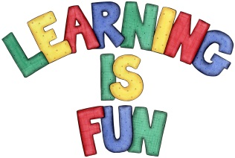
Date Set | Friday 18th November 2016
Date Due | Friday 25th November 2016
Mathletics | 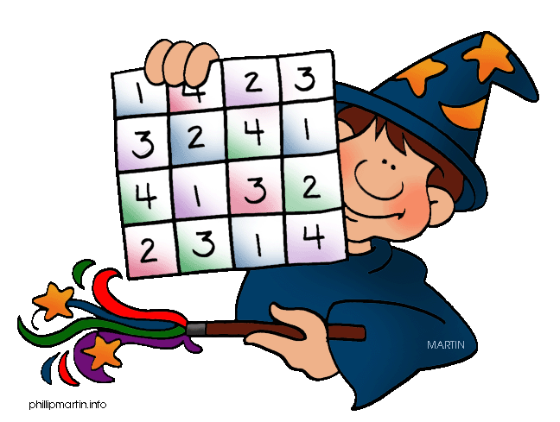  We would like the children to complete the ‘halves and quarters’, ‘make fair shares’ and ‘divide into equal groups’ activities on their Mathletics profile. They will be given shapes on which they need to colour in the given fraction. They will then have to share objects out equally between groups of people and jars.
Spellodrome  Writing | We would like the children to learn words that have the ‘n’ sound spelt with a gn/kn such as knock, knee, know, gnat, gnaw etc.  The children will also be  completing an activity where they need to identify the  correct conjunction (joining word) to make the sentence complete.  For example – Do you want fish and chips for tea?
Reading | Recommended daily reading time:  KS1 15-20 minutes  KS2 40 minutes
Greek | Please go to Greek Class Blog for Greek Home Learning  Greek Class - St Cyprian's Greek Orthodox Primary Academy

