YEAR 2 HOME LEARNING
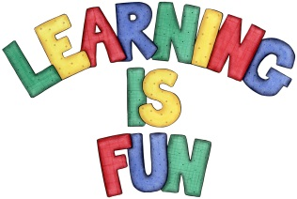
Date Set | Friday 25th November 2016
Date Due | Friday 2nd December 2016
Mathletics | We would like the children to complete the ‘complete the pattern’ activity where they need to select the shape that will go next in the pattern. They will also have to complete the ‘Symmetry’ activity where they need to identify the shapes which are symmetrical. Finally they will have to complete the ‘Fractions of a collection’ activity where they need to find halves or quarters of different numbers.
Spellodrome  Writing | 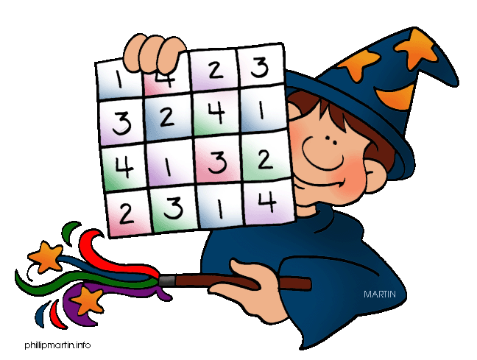  We would like the children to learn words that begin with ‘wr’  such as write, wrote, wrap, wrong, written etc.  The children will also be  completing an activity where they need to identify the  correct verb (doing word) in the past tense to make the sentence complete.  For example – My uncle wrote me a long letter.
Reading | Recommended daily reading time:  KS1 15-20 minutes  KS2 40 minutes
Greek | Please go to Greek Class Blog for Greek Home Learning  Greek Class - St Cyprian's Greek Orthodox Primary Academy

