YEAR 2 HOME LEARNING
Date Set | Friday 22nd September
Date Due | Friday 29th September
Mathletics | 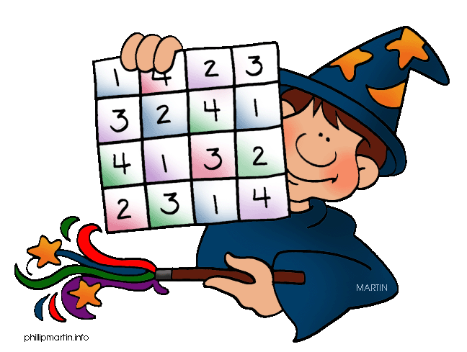  We would like the children to complete the ‘counting on a 100 grid’ activity where they need to use the 100 square to identify patterns and write in the missing numbers. We would also like the children to complete the ’10 more and 10 less’ and the ‘repartition of 2 digit numbers’ where they need to partition the numbers into tens and ones using the rods and ones to support them.
Spellodrome  Writing | We would like the children to learn words that have the g/j  sound in them such as jar, jog, adjust etc.  The children will also be  completing an activity where they need to identify the  sentence with the correct punctuation. For example “The baby was cute. She smiled and laughed a lot.
Reading | Recommended daily reading time:  KS1 15-20 minutes  KS2 40 minutes
Greek | Please go to Greek Class Blog for Greek Home Learning  Greek Class - St Cyprian's Greek Orthodox Primary Academy

