YEAR 2 HOME LEARNING
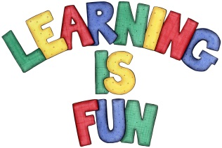
Date Set | Friday 29th September
Date Due | Friday 6th October
Mathletics | We would like the children to complete the ‘Number and Place Value Counting’ activity where they count in 2s, 5s and 10s forward or backwards using a number line. We would also like the children to complete the ’Fractions’ activity ‘Odd and Even’. Children need to count the objects and decide if there is an odd or even number.
Spellodrome  Writing | We would like the children to learn words that have the s sound spelt c such as face, rice, city etc.  The children will also be  completing an activity where they need to select a correct word (adjective) to complete the sentences.  For example ‘The kind man helped me lift the big box.’
Reading | 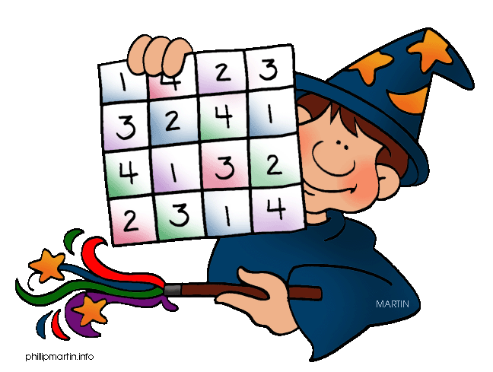  Recommended daily reading time:  KS1 15-20 minutes  KS2 40 minutes
Greek | Please go to Greek Class Blog for Greek Home Learning  Greek Class - St Cyprian's Greek Orthodox Primary Academy

