YEAR 2 HOME LEARNING
Date Set | Friday 13th October
Date Due | Friday 20th October
Mathletics | 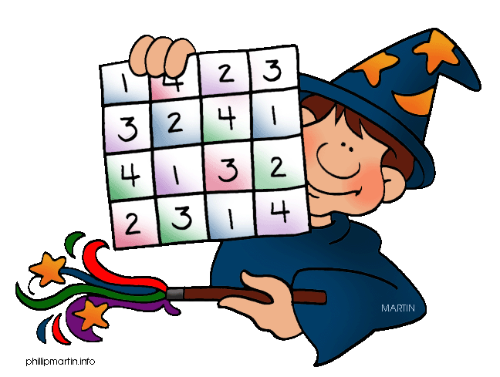  We would like the children to complete the ‘fact families add and subtract’ activity where they need to use the numbers given to make the 2 addition and 2 subtraction calculations e.g. 7, 3, 10 – 7+3=10, 3+7=10, 10-7=3, 10-3=7. We would also like the children to complete the ‘simple subtraction’ activity where they need to solve subtraction calculations. Finally we would like them to complete the ‘money- who’s got it?’ activity where they need to click on the correct  amount of money.
Spellodrome  Writing | We would like the children to learn words that have the r  sound spelt ‘wr’ such as write, wrote, written, wrong etc.  The children will also be  completing an activity where they need to identify the  adverb to complete the sentence. For example “My cold is a lot worse than yours.”
Reading | Recommended daily reading time:  KS1 15-20 minutes  KS2 40 minutes
Greek | Please go to Greek Class Blog for Greek Home Learning  Greek Class - St Cyprian's Greek Orthodox Primary Academy

