YEAR 2 HOME LEARNING
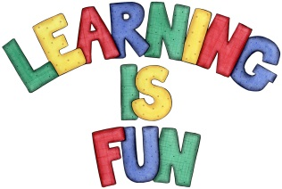
Date Set | Friday 20th October
Date Due | Friday 3rd November
Mathletics | 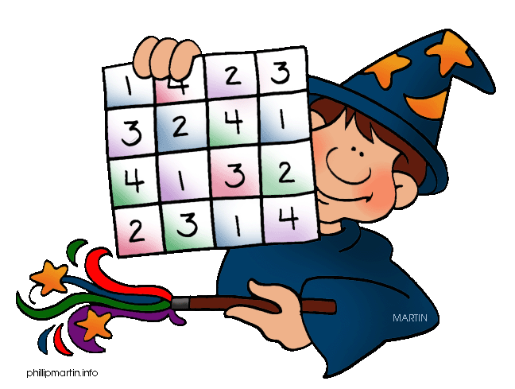  We would like the children to complete the ‘picture graph’ activity where they need to use the picture graph given to answer questions about it. We would also like the children to complete the ‘tallies’ activity where they need to check the tallies with the amount of objects in the picture.
Spellodrome  Writing | We would like the children to learn words that end in ‘le’ such as apple, table, middle, little, bottle etc.  The children will also be  completing an activity where they need to identify the  conjunction to complete the sentence. For example “I would like fish and chips for my tea.”
Reading | Recommended daily reading time:  KS1 15-20 minutes  KS2 40 minutes
Greek | Please go to Greek Class Blog for Greek Home Learning  Greek Class - St Cyprian's Greek Orthodox Primary Academy

