YEAR 2 HOME LEARNING
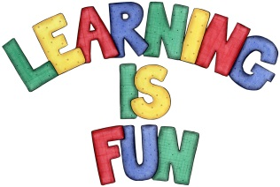
Date Set | Friday 6th October
Date Due | Friday 13th October
Mathletics | 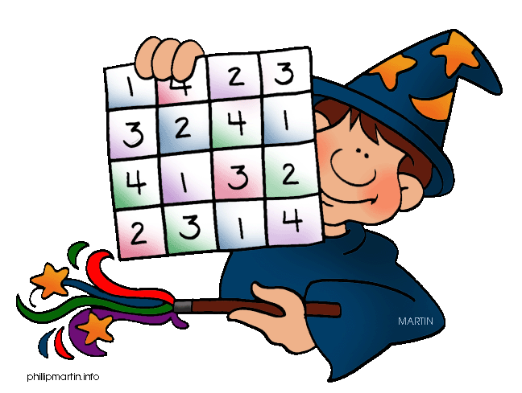  We would like the children to complete the ‘counting in 2s’ ‘counting in 5s’ and ‘counting in 10s’ activities where they have to click on the missing number in the sequence which is either counting in 2s, 5s or 10s.
Spellodrome  Writing | We would like the children to learn words that have the ‘n’  sound spelt kn/gn such as knock, knit, gnat, gnaw etc.  The children will also be  completing an activity where they need to identify the  sentence/s with the full stops in the correct places. For example “We saw lots of fish in the sea. They were beautiful.’ There will be 4 options to choose from so you may need to scroll down.
Reading | Recommended daily reading time:  KS1 15-20 minutes  KS2 40 minutes
Greek | Please go to Greek Class Blog for Greek Home Learning  Greek Class - St Cyprian's Greek Orthodox Primary Academy

