YEAR 2 HOME LEARNING
Date Set | Friday 1st December
Date Due | Friday 8th December
Mathletics | We would like the children to complete the ‘collect all shapes’ activity where they need to put all of the identified shapes in the frame. We would also like the children to complete the ‘Count the sides and corners’ activity where they need to place in the frame all of the shapes with the identified number of sides or corners.
Spellodrome  Writing | 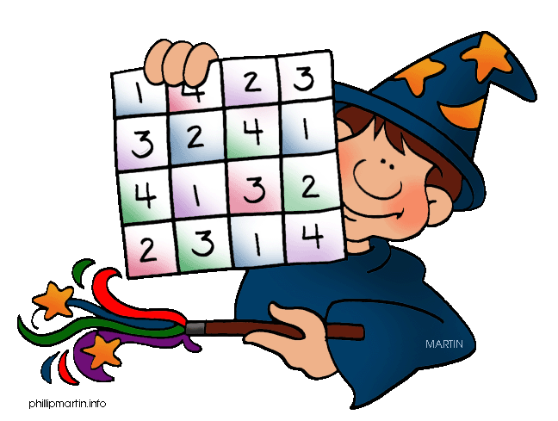  We would like the children to learn words that end in y but in the plural changes to an i and adds es, such as cries, tries, flies etc.  The children will also be  completing an activity where they need to identify the  correct contraction to complete the sentence. For example  “Isn’t it a lovely day today”
Reading | Recommended daily reading time:  KS1 15-20 minutes  KS2 40 minutes
Greek | Please go to Greek Class Blog for Greek Home Learning  Greek Class - St Cyprian's Greek Orthodox Primary Academy

