YEAR 2 HOME LEARNING
Date Set | Friday 10th November
Date Due | Friday 17th November
Mathletics | 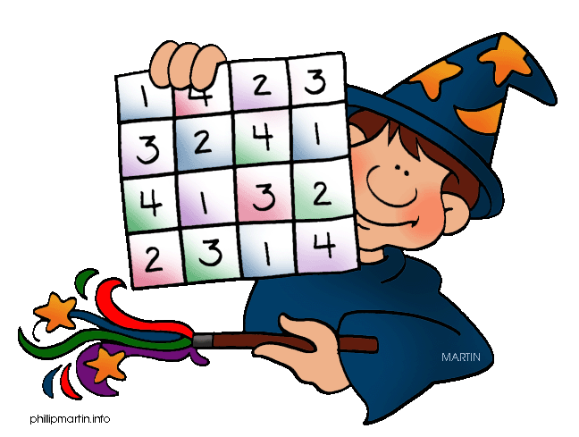  We would like the children to complete the ‘shade fractions’ and ‘halves and quarters’ activities where they need to colour in the fraction shown on each shape. We would also like the children to complete the ‘fractions of a collection’ activity where they need to share the amount of objects into either halves or quarters and identify the answer.
Spellodrome  Writing | We would like the children to learn words that end in ‘al’  such as metal, pedal, capital, hospital, animal etc.  The children will also be  completing an activity where they need to identify the  verb to complete the sentence. For example “The boy kicked the ball across the grass.”
Reading | Recommended daily reading time:  KS1 15-20 minutes  KS2 40 minutes
Greek | Please go to Greek Class Blog for Greek Home Learning  Greek Class - St Cyprian's Greek Orthodox Primary Academy

