YEAR 2 HOME LEARNING
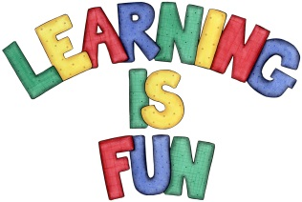
Date Set | Friday 17th November
Date Due | Friday 24th November
Mathletics | 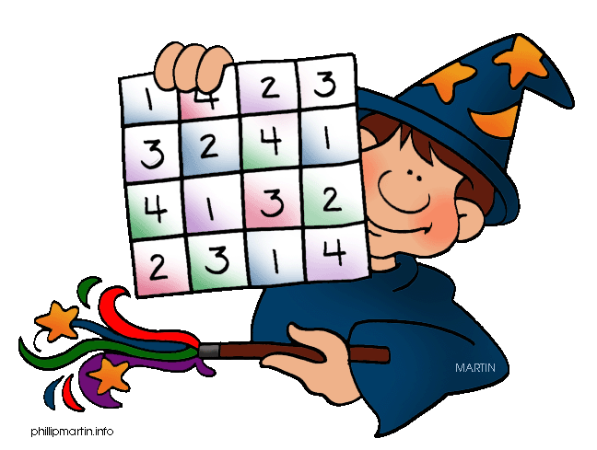  We would like the children to complete the ‘divide into equal groups’ activity where they need to work out how many groups they would need to split the objects into equal groups. We would also like the children to complete the ‘make fair shares’ activity where they need to share the amount of objects equally between the children.
Spellodrome  Writing | We would like the children to learn words that end in ‘il’  such as fossil, pencil, April, until etc.  The children will also be  completing an activity where they need to identify the  pronoun to complete the sentence. For example “The boy kicked the ball to us.”
Reading | Recommended daily reading time:  KS1 15-20 minutes  KS2 40 minutes
Greek | Please go to Greek Class Blog for Greek Home Learning  Greek Class - St Cyprian's Greek Orthodox Primary Academy

