YEAR 2 HOME LEARNING
Date Set | Friday 24th November
Date Due | Friday 1st December
Mathletics | 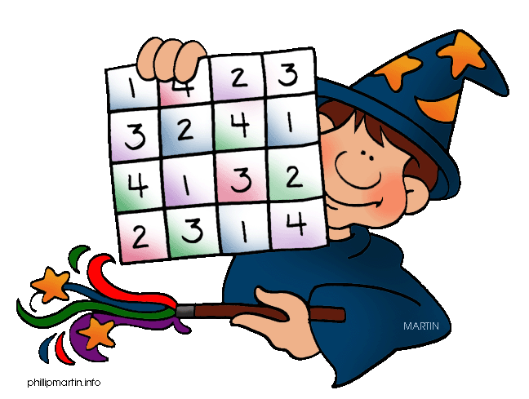  We would like the children to complete the ‘uneven partitioned shapes’ activity where they need to click on the correctly shaded fraction of the shape. We would also like the children to complete the ‘symmetry’ activity where they need to identify the symmetrical objects.
Spellodrome  Writing | We would like the children to learn words that end in ‘y’  such as cry, fly, try, July, reply etc.  The children will also be  completing an activity where they need to identify the  position of the comma to complete the sentence. For example “The children were excited, nervous and loud during the show.”
Reading | Recommended daily reading time:  KS1 15-20 minutes  KS2 40 minutes
Greek | Please go to Greek Class Blog for Greek Home Learning  Greek Class - St Cyprian's Greek Orthodox Primary Academy

