YEAR 2 HOME LEARNING
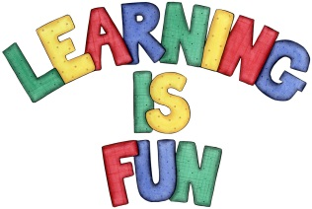
Date Set | Friday 3rd November
Date Due | Friday 10th November
Mathletics | We would like the children to complete the ‘Count Backwards Pattern’ activity where they count backwards to find the missing number. Children can use a number line or a 100 square to help.  We would also like the children to complete the ’Magic Mental Subtraction’ activity. Children need to subtract the numbers using a number line or a 100 square.
Spellodrome  Writing | We would like the children to learn words that have the el sound such as level, label, tunnel etc.  The children will also be  completing a description task activity where they need to choose a person or an object and describe it in detail. Children need to use adjectives to describe in detail what something/ someone looks like, sounds like, smells like, feels like, does.  For example ‘My Dad has big brown eyes.’
Reading | 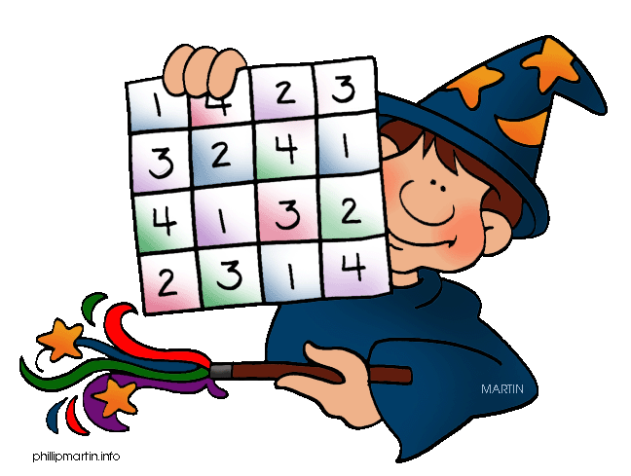  Recommended daily reading time:  KS1 15-20 minutes  KS2 40 minutes
Greek | Please go to Greek Class Blog for Greek Home Learning  Greek Class - St Cyprian's Greek Orthodox Primary Academy

