YEAR 2 HOME LEARNING
Date Set | Friday 12th January
Date Due | Friday 19th January
Mathletics | We would like the children to complete the ‘repartition of 2 digit numbers’ activity where they need to put the tens rods and ones cubes to make the correct numbers. We would also like the children to complete the ‘Place Value’ activity where they need to write down the number shown on the abacus.
Spellodrome  Writing | 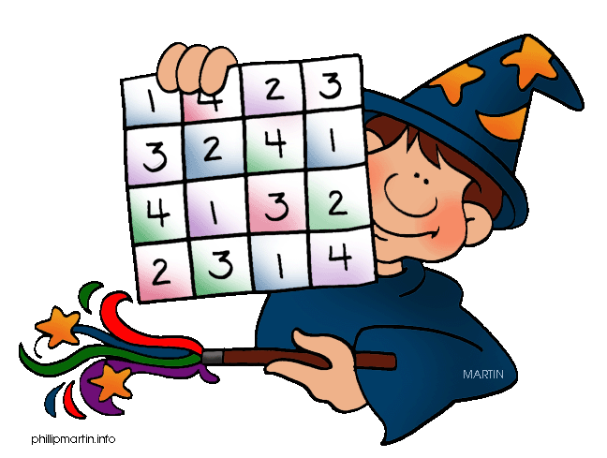  We would like the children to learn words that end in e but changes when adding suffixes, such as hiking, shiny, shinier etc.  The children will also be  completing an activity where they need to identify the  correct punctuation in the sentence. For example  “I like going to the park. I get to go on the swings.” There should be 4 options for each question so you may need to scroll down.
Reading | Recommended daily reading time:  KS1 15-20 minutes  KS2 40 minutes
Greek | Please go to Greek Class Blog for Greek Home Learning  Greek Class - St Cyprian's Greek Orthodox Primary Academy

