YEAR 2 HOME LEARNING
Date Set | Friday 19th January
Date Due | Friday 26th January
Mathletics | We would like the children to complete the ‘groups of 10’ and ‘groups of 5’ activities where they need to identify how many groups of 5 or 10 they have and what the total amount is.
Spellodrome  Writing | 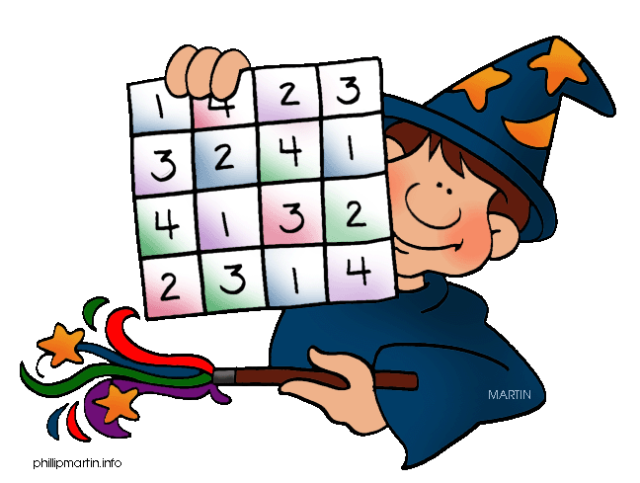  We would like the children to learn words that double the constant when adding the suffixes –er, -ing, -ed, -est.  The children will also be  completing an activity where they need to identify where  the question mark or exclamation mark should go in the sentence. There should be 3/4 options for each question so you may need to scroll down.
Reading | Recommended daily reading time:  KS1 15-20 minutes  KS2 40 minutes
Greek | Please go to Greek Class Blog for Greek Home Learning  Greek Class - St Cyprian's Greek Orthodox Primary Academy

