YEAR 2 HOME LEARNING
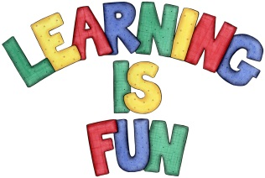
Date Set | Friday 2nd February
Date Due | Friday 9th February
Mathletics | We would like the children to complete the ‘Dividing by Tens, Fives and Twos’ activities where they have to work out how many equal groups they would have when they are dividing by those numbers.
Spellodrome  Writing | 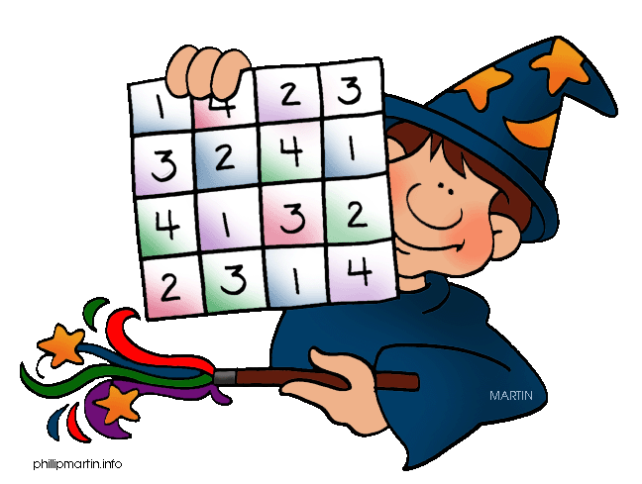  We would like the children to learn words that have the ‘o’ sound in them such as other, mother, brother, etc.  The children will also be  completing an activity where they need to write the  correct spelling for the underlined word in the sentence.  E.g. We ran up the hil.
Reading | Recommended daily reading time:  KS1 15-20 minutes  KS2 40 minutes
Greek | Please go to Greek Class Blog for Greek Home Learning  Greek Class - St Cyprian's Greek Orthodox Primary Academy

