YEAR 2 HOME LEARNING
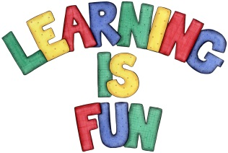
Date Set | Friday 23rd February
Date Due | Friday 2nd March
Mathletics | We would like the children to complete the ‘missing numbers’ activity where they have to work out what the missing number to the calculation is. We would also like the children to complete the ‘Count the corners’ activity where they need to work out how many corners each of the shapes have.
Spellodrome  Writing | 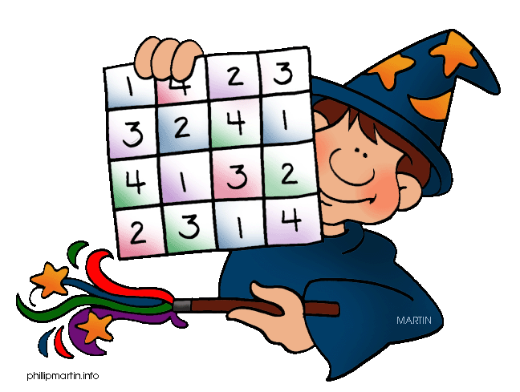  We would like the children to learn words that have a but sound like o such as want, watch, squash, quantity, etc.  We would like the children to complete an apostrophe  activity where they need to identify the sentence that  uses apostrophes correctly e.g. These are Mary’s pens. There are 4 options so you may need to scroll further down.
Reading | Recommended daily reading time:  KS1 15-20 minutes  KS2 40 minutes
Greek | Please go to Greek Class Blog for Greek Home Learning  Greek Class - St Cyprian's Greek Orthodox Primary Academy

