YEAR 2 HOME LEARNING
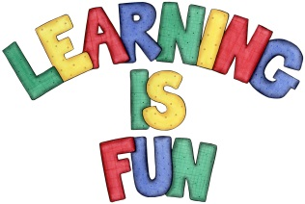
Date Set | Friday 2nd March
Date Due | Friday 9th March
Mathletics | We would like the children to complete the ‘arranging numbers’ activity where they have to work out which number is biggest and which is smallest. We would also like the children to complete the ‘relate shapes and solids’ activity where they need to click on the name of the shape highlighted.
Spellodrome  Writing | 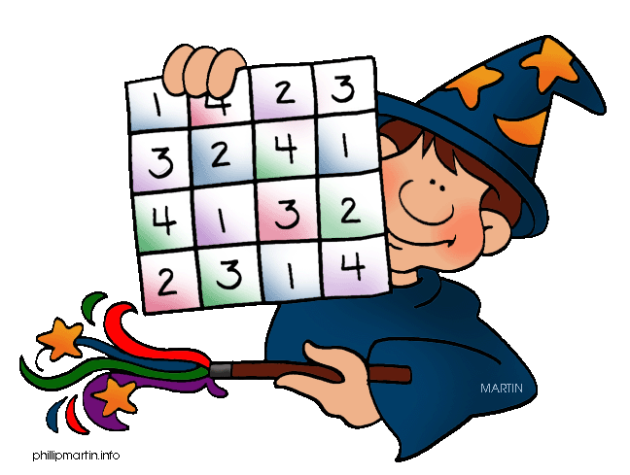  We would like the children to learn words that are spelt or but says er e.g. word, work, worm, world etc.  We would like the children to complete a making plurals  activity where they need to identify the sentence that  has the correct plural in it.  There are 4 options so you may need to scroll further down.
Reading | Recommended daily reading time:  KS1 15-20 minutes  KS2 40 minutes
Greek | Please go to Greek Class Blog for Greek Home Learning  Greek Class - St Cyprian's Greek Orthodox Primary Academy

