YEAR 2 HOME LEARNING
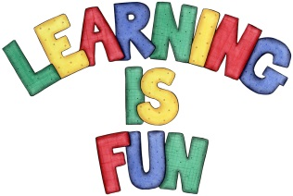
Date Set | Friday 27th April
Date Due | Friday 4th May
Mathletics | We would like the children to complete the ‘Fractions of a collection’ and ‘Make Fair Shares’ activities where they have to share the objects equally into halves and quarters.
Spellodrome  Writing | 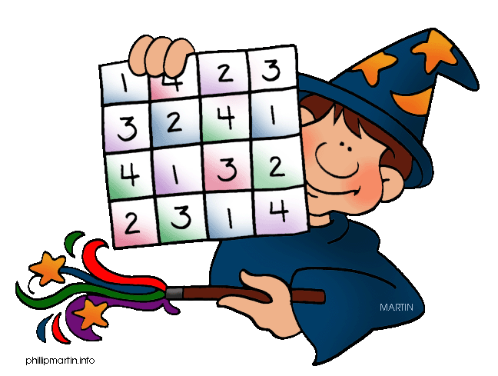  We would like the children to learn contractions (words with parts missing) such as didn’t, hasn’t couldn’t it’s I’ll, etc.  The children will also be  completing an activity where they need to spell the  missing word to complete the sentence  e.g. The boy loved his box of magic tricks.
Reading | Recommended daily reading time:  KS1 15-20 minutes  KS2 40 minutes
Greek | Please go to Greek Class Blog for Greek Home Learning  Greek Class - St Cyprian's Greek Orthodox Primary Academy

