YEAR 2 HOME LEARNING
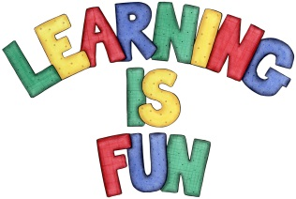
Date Set | Friday 11th May
Date Due | Friday 18th May
Mathletics | We would like the children to complete the ‘Who’s got it?’ and ‘How much change?’ activities where they need to click on the coins to work out the correct amount.
Spellodrome  Writing | 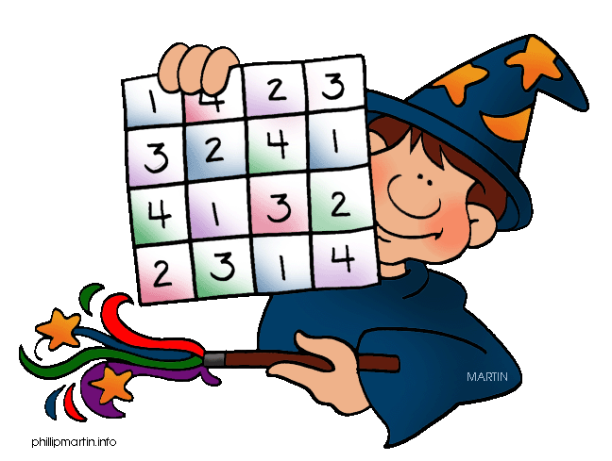  We would like the children to learn homophones such as there/their/they’re, here/hear, sea/see etc.  The children will also be  completing an activity where they need to spell the  incorrect word with a suffix or prefix correctly.  e.g. The fireman was fearliss (fearless) going into the burning building.
Reading | Recommended daily reading time:  KS1 15-20 minutes  KS2 40 minutes
Greek | Please go to Greek Class Blog for Greek Home Learning  Greek Class - St Cyprian's Greek Orthodox Primary Academy

