YEAR 2 HOME LEARNING
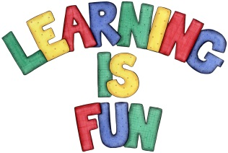
Date Set | Friday 8th June
Date Due | Friday 15th June
Mathletics | We would like the children to complete the ‘How Heavy?’ activity where they have to weigh the object and say how heavy it is. We would also like the children to complete the ‘Ordering Mass’ activity where they need to put the different weights in the correct order.
Spellodrome  Writing | 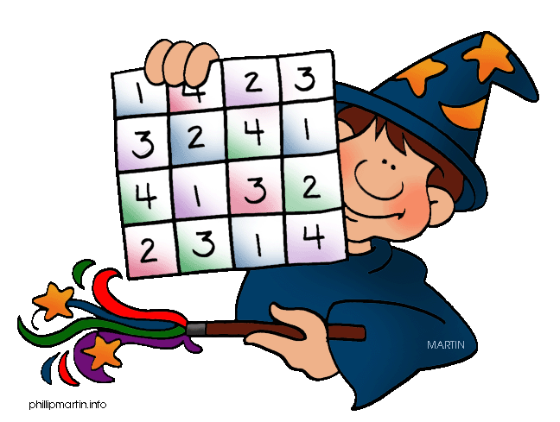  We would like the children to learn tricky words such as door, floor, poor, because, kind, find etc.  The children will also be  completing an activity where they need to identify the  correct noun to complete the sentence.  e.g. I went to New York on holiday.  Unfortunately this activity is not compatible with tablets.
Reading | Recommended daily reading time:  KS1 15-20 minutes  KS2 40 minutes
Greek | Please go to Greek Class Blog for Greek Home Learning  Greek Class - St Cyprian's Greek Orthodox Primary Academy

