YEAR 3 HOME LEARNING
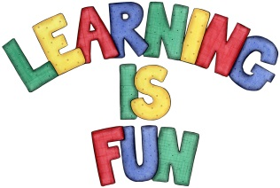
Date Set | 05/10/18
Date Due | 10/10/18
Mathletics | This week will be focussing on written addition using the column method. All activities can be found on matheletics.com. Every child has their username and passwords in their reading records.
Spellodrome  Writing | This week children will be focusing on words with ‘ai’ sound spelt ‘ei’, ‘eigh’ or ‘ey’:  - they  - grey  - beige  - sleigh  - neighbour  - eight  - eighth  - weight  - reign  - height  Spellings can also be found on spellodrome.com if you would like extra practice.  Writing task  In class, we have been learning how to find information from non-fiction sources. This week, I would like you to write a report on your favourite animal. Try to include:  - Title  - Headings and subheadings  - Statement sentences and interesting information.
Reading | Recommended daily reading time:  KS2 40 minutes.
Home Learning Project | During inclusion week we will be celebrating Black History Month. This year our theme will be ‘Heroes’. We are focussing on Mary Seacole and would like a presentation of their work.  As a whole school, we invite children to create a piece of learning on any hero from black history of their choice. They could create a poster, a leaflet or anything imaginative. We can’t wait to see how creative the children will be!  Date Set: 03/10/18 Date Due: 19/10/18
Greek | Please go to Greek Class Blog for Greek Home Learning  Greek Class - St Cyprian's Greek Orthodox Primary Academy

