YEAR 2 HOME LEARNING
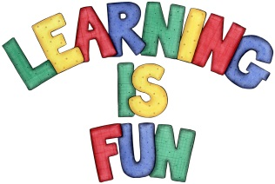
Date Set | 12.10.18
Date Due | 17.10.18
Mathletics | On Matheletics focus on the multiples of 2,3,5 and 10 and learning how to sequence numbers. Additionally, focus on calculating capacity using litres. All activities can be found on matheletics.com. Every child has their username and passwords in their reading records.
Spellodrome  Writing | This week children will be focusing on these spellings:  - knock  - know  - knee  - gnat  - gnaw  Your home learning challenge this week is to make an information booklet about the Great Fire of London. You need to include:  - Factual information  - Headings and sub-headings such as: How do we know about the Great Fire of London? How did the Great Fire start? What happened after the Great Fire? How is the Great Fire remembered?  - Drawings and captions  - Information on Thomas Faynor, Samuel Peeps and Christopher Wren.  - Fun Facts
Reading | Recommended daily reading time:  KS1 20 minutes.
Home Learning Project | Date Set: N/A Date Due:
Greek | Please go to Greek Class Blog for Greek Home Learning  Greek Class - St Cyprian's Greek Orthodox Primary Academy

