YEAR 3 HOME LEARNING
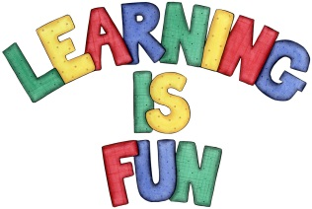
Date Set | 09/11/18
Date Due | 14/11/18
Mathletics | This week will be continuing our work with fractions and will also be focussing on pictograms and Carroll diagrams. All activities can be found on matheletics.com. Every child has their username and passwords in their reading records.
Spellodrome  Writing | This week children will be focusing on words with un- prefix.  - Redo  - Return  - Replay  - Refill  - Revisit  - Replace  - Recycle  - Reappear  - Rebuild  - Reposition  Spellings can also be found on spellodrome.com if you would like extra practice.  Writing Task  This week we have been looking at the difference between formal and informal letters. For your home learning this week, we would like you to write an informal letter to someone in your class.  Please remember to include: the address, date, greetings and a friendly message. This home learning is due Wednesday 14th November 2018.
Reading | Recommended daily reading time:  KS2 40 minutes.
Home Learning Project | Date Set: n/a Date Due: n/a
Greek | Please go to Greek Class Blog for Greek Home Learning  Greek Class - St Cyprian's Greek Orthodox Primary Academy

