YEAR 2 HOME LEARNING
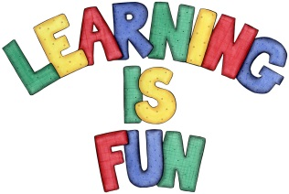
Date Set | 16.11.18
Date Due | 21.11.18
Mathletics | On Matheletics focus on fractions and finding halves of shapes and numbers. Additionally, focus on money and making different amounts using different coins as well as identifying and learning about the pound and pence sign. All activities can be found on matheletics.com. Every child has their username and passwords in their reading records.
Spellodrome  Writing | This week children will be focusing on these spellings:  - fossil  - council  - until  - pencil  - April  Your home learning challenge this week is to pretend that you are an explorer that has just stumbled across this house. You need to write a brief description to describe the setting and explain:  - Where the house is set e.g. forest, jungle, high up in the mountains etc.?  - What does it look like, smell like, feel like etc.?  - Who might live there and why?  - What did you discover when you arrived there?  Be as imaginative and creative as possible and use as many adjectives as you can!!!!
Reading | Recommended daily reading time:  KS1 20 minutes.
Home Learning Project | Date Set: N/A Date Due:
Greek | Please go to Greek Class Blog for Greek Home Learning  Greek Class - St Cyprian's Greek Orthodox Primary Academy

