YEAR 2 HOME LEARNING
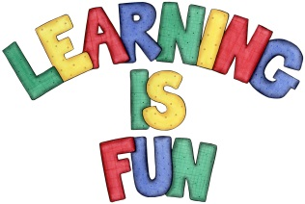
Date Set | 23.11.18
Date Due | 28.11.18
Mathletics | On Matheletics focus on fractions and finding halves of shapes and numbers. Additionally, focus on money and making different amounts using different coins as well as identifying and learning about the pound and pence sign. All activities can be found on matheletics.com. Every child has their username and passwords in their reading records.
Spellodrome  Writing | This week children will be focusing on these spellings:  - cry  - fly  - dry  - try  - reply  - July  Your home learning challenge this week is to pretend that you are either the Big Bad Wolf from the fairy tale ‘The Three Little Pigs,’ or one of the three little pigs. You need to write a diary entry from the point of view of one of the characters. You must include the following:  - Write in first person using ‘I’ and include capital letters and full stops.  - Write in past tense  - Explain what happened that day  - How did you feel?  - What did you do after?
Reading | Recommended daily reading time:  KS1 20 minutes.
Home Learning Project | Date Set: N/A Date Due:
Greek | Please go to Greek Class Blog for Greek Home Learning  Greek Class - St Cyprian's Greek Orthodox Primary Academy

