YEAR 3 HOME LEARNING
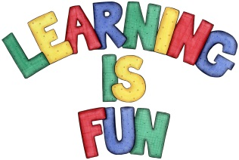
Date Set | 07/12/18
Date Due | 12/12/18
Mathletics | This week will be reviewing what we have learnt over the autumn term. This includes, adding and subtracting mentally, fractions, times tables and angles.
Spellodrome  Writing | This week children will be revising words from previous spelling challenges.  - happily  - sadly  - badly  - elderly  - honestly  - mostly  - smelly  - brightly  - exactly  - friendly  Spellings can also be found on spellodrome.com if you would like extra practice.  Writing Task  Imagine you have built a snowman and it has come to life. Describe the moment when it realises it can move. Describe it moving gently and carefully at first. Describe what it decides to do. What happens next? This home learning is due Wednesday 12th December 2018.
Reading | Recommended daily reading time:  KS2 40 minutes.
Home Learning Project | Date Set: n/a Date Due: n/a
Greek | Please go to Greek Class Blog for Greek Home Learning  Greek Class - St Cyprian's Greek Orthodox Primary Academy

