YEAR 5 HOME LEARNING
Date Set | 14.12.18
Date Due | 21.12.18
Mathletics | This week will be focussing on TIME. All activities can be found on the following website: http://uk.mathletics.com/ Every child has their username and passwords in their reading records.
Spellodrome  Writing | This week children will be focusing on 100 key words:  Spelling can also be found on http://www.spellodrome.com.au/#/home  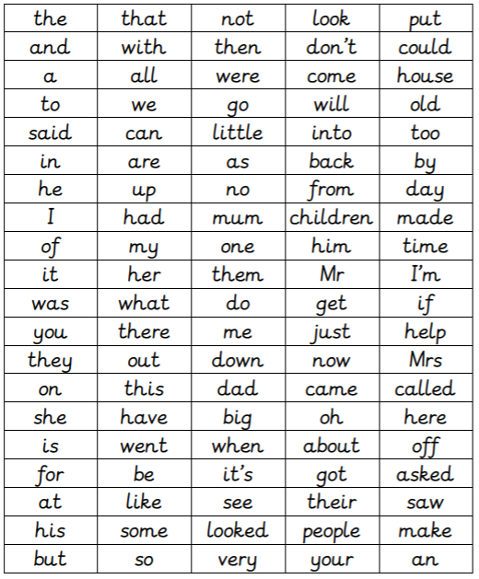  Writing task – Due  This week I would like the children to write a recount of the nativity story. Children to include relative clauses, complex sentences and parentheses. Each paragraph also needs to begin with a fronted adverbial.
Reading | Recommended daily reading time:  KS2 40 minutes.
Home Learning Project | Date Set: Date Due:
Greek | Please go to Greek Class Blog for Greek Home Learning  Greek Class - St Cyprian's Greek Orthodox Primary Academy

