YEAR 3 HOME LEARNING
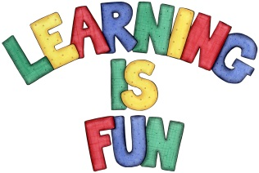
Date Set | 14/12/18
Date Due | 19/12/18
Mathletics | This week will be reviewing what we have learnt over the autumn term. This includes, adding and subtracting mentally, fractions, times tables and angles.
Spellodrome  Writing | This week children will be learning Christmas-themed words!  - Reindeer  - Christmas  - Sensations  - Rudolph  - Santa Claus  - Jesus  - Manger  - Worship  - Donkey  - Geography  Spellings can also be found on spellodrome.com if you would like extra practice.  Writing Task  For your home learning this week I would like you to write about how you celebrate Christmas. I would like at least one page of writing. This home learning is due Wednesday 19th December 2018.
Reading | Recommended daily reading time:  KS2 40 minutes.
Home Learning Project | Date Set: n/a Date Due: n/a
Greek | Please go to Greek Class Blog for Greek Home Learning  Greek Class - St Cyprian's Greek Orthodox Primary Academy

