YEAR 3 HOME LEARNING
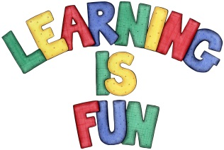
Date Set | 30/11/18
Date Due | 05/12/18
Mathletics | This week will be focussing angles and fractions. All activities can be found on matheletics.com. Every child has their username and passwords in their reading records.
Spellodrome  Writing | This week children will be revising words from previous spelling challenges.  - fearless  - myth  - encourage  - neighbour  - reign  - search  - disbelieve  - misplace  - business  - reappear  Spellings can also be found on spellodrome.com if you would like extra practice.  Writing Task  This week in class, we have been learning how to use inverted commas for dialogue. This week I would like you to write a story about Bob, the Man on the Moon. The story must be told mainly through dialogue. Try to use different sentence openers ad think of words you could use instead of ‘said’. Remember, exciting stories have different sentence types.
Reading | Recommended daily reading time:  KS2 40 minutes.
Home Learning Project | Date Set: n/a Date Due: n/a
Greek | Please go to Greek Class Blog for Greek Home Learning  Greek Class - St Cyprian's Greek Orthodox Primary Academy

