YEAR 2 HOME LEARNING
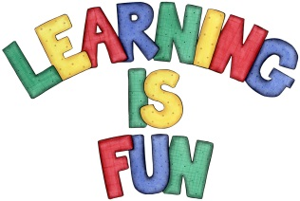
Date Set | 25.1.19
Date Due | 30.1.19
Mathletics | On Matheletics focus on finding the multiples of 5 and 10. Also focus on division and finding the inverse of operations. For example  15 ÷5 = 3 so 3x5=15. If children are confident in the 2, 5 and 10 times tables please start learning the 3, 4 and 6 times tables. If children are secure in all of the above start learning the 7, 8 and 9 times tables. All activities can be found on matheletics.com. Every child has their username and passwords in their reading records.
Spellodrome  Writing | For your writing challenge this week you need to research animals which are either mammals, birds, fish, reptiles, or amphibians. You can choose a group and focus on animals within that group or could investigate different animals from different categories. You need to create a fact file on them and investigate:  - The lifecycle and a labelled diagram of each animal/animals  - How they change from a baby to an adult  - Diet  - Habitat and where they can be found and country  - Fun Facts about them  - Use of connectives to extend your sentences e.g. but, because, then, while, when etc.  - Subheadings and Headings  - Glossary  - Full stops and capital letters in the correct places.  You need to write at least a page.  Spellings to learn this week  - patting  - patted  - humming  - hummed  - dropping  - dropped
Reading | Recommended daily reading time:  KS1 20 minutes.
Home Learning Project | Date Set: Date Due:
Greek | Please go to Greek Class Blog for Greek Home Learning  Greek Class - St Cyprian's Greek Orthodox Primary Academy

