YEAR 1 HOME LEARNING
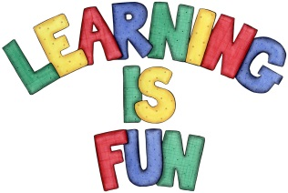
Date Set | 11.01.19
Date Due | 17.01.19
Mathletics | Will be set next week.
Spellodrome  Writing | Set spellings: words with ff, ll, ss, zz, ck, nk and words ending in y.  Every Friday we will set spellings and a writing task. Please check your child’s Pink Home Learning book for more details.  Hand in: By the following Wednesday.
Reading | Recommended daily reading time:  KS1 15-20 minutes
Home Learning Project | Date Set:11.01.19 Date Due: 24.01.19  Year 1 Home Learning  Our topic for this half term is “What plants or animals would Little Red Riding Hood see in our local area?”  We would like you to create a poster or 3D model of a plant or tree you can see in your garden or local park.  Your posters and models will be a part of our topic wall, so be as creative as you can be.  If you need any assistance, please come and see Miss Cabigas or Miss Nugent.
Greek | Please go to Greek Class Blog for Greek Home Learning  Greek Class - St Cyprian's Greek Orthodox Primary Academy
