YEAR 3 HOME LEARNING
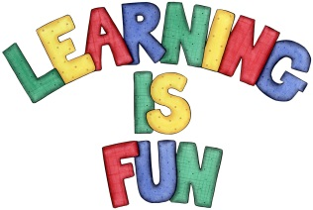
Date Set | 25.2.19
Date Due | 06.03.19
Mathletics | This week in maths we will be learning how to use the bus stop method for division.
Spellodrome  Writing | This week children will be revising words from previous spelling challenges.  This week’s spellings:  - League  - Plague  - Rogue  - Vague  - Fatigue  - Unique  - Antique  - Cheque  - Mosque  - technique  Spellings can also be found on spellodrome.com if you would like extra practice.  Writing Task  This week in school we will be learning how to write instructions. For your homework this week I would like you to write instructions on how to make a traditional dish from your culture, or one of your favourite foods. It must include:  A goal, ingredients/materials/equipment needed, sequenced steps – numbers, bullets or alphabet, prepositions, imperative (bossy) verbs and it must be in chronological order.
Reading | Recommended daily reading time:  KS2 20 minutes.
Home Learning Project | Date Set: 25.02.19 Date Due: 06.03.19
Greek | Please go to Greek Class Blog for Greek Home Learning  Greek Class - St Cyprian's Greek Orthodox Primary Academy

