YEAR 2 HOME LEARNING
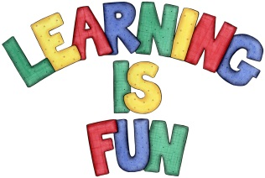
Date Set | 1.3.19
Date Due | 6.3.19
Mathletics | On Matheletics focus on finding fractions of shapes and numbers. Also focus on symmetry of 2D shapes and finding reflective symmetry. If children are confident in the 2, 5 and 10 times tables please start learning the 3, 4 and 6 times tables. All activities can be found on matheletics.com. Every child has their username and passwords in their reading records.
Spellodrome  Writing | We have been learning about ‘Explanation Texts’. We have learnt that Explanation texts explain to us how a process works. To help us understand this we have identified their key features (pictures/diagrams, ordered paragraphs, joining words: because, this means, so etc, comparative words: brighter, smaller etc, technical vocabulary: mammals, nutrients etc and glossary) by exploring different texts about animals. For your writing challenge this week I would like you to choose two animals and write a comparison of them both. You need to include in your writing:  - The use of comparative words such as: smaller, heaviest etc.  - The name of your animals.  - Some extended sentences (and, so, because, if, when, such as).  - Full stops and capital letters in the correct places.  Present your learning in a creative way and write at least a page for your comparison.  Spellings to learn this week  - key  - donkey  - monkey  - chimney  - valley
Reading | Recommended daily reading time:  KS1 20 minutes.
Home Learning Project | Date Set: Date Due:
Greek | Please go to Greek Class Blog for Greek Home Learning  Greek Class - St Cyprian's Greek Orthodox Primary Academy

