YEAR 2 HOME LEARNING
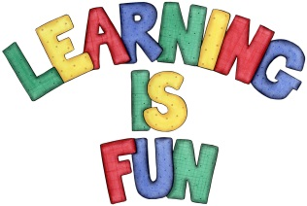
Date Set | 15.2.19
Date Due | 27.2.19
Mathletics | On Matheletics focus on writing simple fractions 1/2, 2/4, 1/4 and 3/4 and finding them in shapes. Focus on finding 1/2 and 1/4 of numbers. Also focus on reflective symmetry of shapes. If children are confident in the 2, 5 and 10 times tables please start learning the 3, 4 and 6 times tables. If children are secure in all of the above start learning the 7, 8 and 9 times tables. All activities can be found on matheletics.com. Every child has their username and passwords in their reading records.
Spellodrome  Writing | Your Homework challenge over the holidays is to pretend that you are at a luxurious holiday resort surrounded by a beautiful seaside. You need to either write a letter or design and write a postcard. In your letter or postcard, you must include:  - What have you been doing on your holiday?  - What you have done so far and what you are going to do e.g. take a boat trip, swim with dolphins, go on rides?  - What has been your favourite part of your holiday?  - What are the features of the seaside resort and attractions?  - What can you do at the seaside?  Your home learning project for over the holidays is to create a musical instrument made out of recyclable materials.  Spellings to learn this week  - other  - mother  - brother  - nothing  - Monday  - money
Reading | Recommended daily reading time:  KS1 20 minutes.
Home Learning Project | Creating and designing a musical Instrument made from recyclable material  Date Set: 15.2.19 Date Due: 27.2.19
Greek | Please go to Greek Class Blog for Greek Home Learning  Greek Class - St Cyprian's Greek Orthodox Primary Academy

