YEAR 1 HOME LEARNING
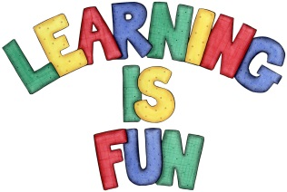
Date Set | 01.03.19
Date Due | 08.03.19
Mathletics | Place value and measurement.
Spellodrome  Writing | Set spellings: words with ff, ll, ss, zz, ck, nk and words ending in y.  Every Friday we will set spellings and a writing task. Please check your child’s Pink Home Learning book for more details.  Hand in: By the following Wednesday.
Reading | Recommended daily reading time:  KS1 15-20 minutes
Home Learning Project | Date Set:01.03.19 Date Due: 08.3.19  Year 1 Home Learning  Our topic for this half term is “Who was famous when mum and dad were little?”  To start off our topic we would like you to write a brief fact file about someone who was famous when your mum and dad were little. E.G Princess Diana and Nelson Mandela.  We look forward to reading your fact files. If you need any help please see Miss Cabigas or Mrs Ahmed.
Greek | Please go to Greek Class Blog for Greek Home Learning  Greek Class - St Cyprian's Greek Orthodox Primary Academy
