YEAR 2 HOME LEARNING
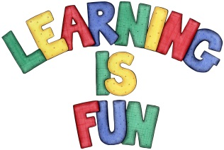
Date Set | 5.4.19
Date Due | 10.4.19
Mathletics | On Matheletics focus on position, direction and motion using straight lines, turns and co-ordinates. Also focus on measuring weight using grams and kilograms. If children are confident in the 2, 5 and 10 times tables please start learning the 3, 4 and 6 times tables. All activities can be found on matheletics.com. Every child has their username and passwords in their reading records.
Spellodrome  Writing | We have been exploring the story of ‘The Lighthouse Keeper’s Lunch’ by Ronda and David Armitage. This is the story of a lighthouse keeper called Mr Grinling who does not receive his lunch as the seagulls keep eating it. We have predicted what we think will happen next, created ideas on how to stop the seagull and described how the characters’ feelings change throughout out the story.  For your writing challenge we would like you to imagine that you are one of the seagulls and write a letter to Mr and Mrs Grinling apologising for eating his lunch. You need to include in your writing:  - ‘I’ when describing why you ate his lunch.  - WOW words to describe your feelings/how it would have made Mr Grinling feel (try to avoid – nice, happy and sad)  - Full stops and capital letters in the correct places.  - Use of because to explain why you ate his lunch.  You need to write at least a page  Spellings to learn this week  - merriment  - happiness  - plentiful  - penniless  - happily
Reading | Recommended daily reading time:  KS1 20 minutes.
Home Learning Project | Date Set: Date Due:
Greek | Please go to Greek Class Blog for Greek Home Learning  Greek Class - St Cyprian's Greek Orthodox Primary Academy

