YEAR 3 HOME LEARNING
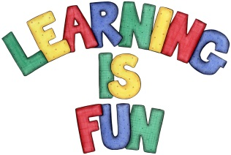
Date Set | 03.05.19
Date Due | 08.05.19
Mathletics | Please check Mathletics for extra practise.
Spellodrome  Writing | This week children will be revising words from previous spelling challenges.  This week’s spellings:  - measure  - pleasure  - treasure  - leisure  - closure  - enclosure  - composure  - picture  - mixture  - secure  Spellings can also be found on spellodrome.com if you would like extra practice.  Writing Task  For your home learning this week I would like you to write a piece of dialogue between two of your favourite characters. They can be any characters that you like and the conversation must be told mainly through speech. Remember to use different sentence types and of course inverted commas! Think about what your characters may say to each other, do they like each other? Have they had a disagreement? This home learning is due Wednesday 8th May 2019.
Reading | Recommended daily reading time:  KS2 20 minutes.
Home Learning Project | Date Set: 03.05.19 Date Due: 08.05.19
Greek | Please go to Greek Class Blog for Greek Home Learning  Greek Class - St Cyprian's Greek Orthodox Primary Academy

