YEAR 2 HOME LEARNING
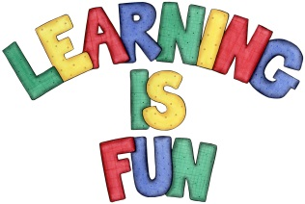
Date Set | 24.5.19
Date Due | 29.5.19
Mathletics | On Matheletics focus on solving and calculating money problems and word problems in pounds and pence using addition and subtraction of decimals. If children are confident in the 2, 5 and 10 times tables please start learning the 3, 4, 6, 7, 8 and 9 times tables. All activities can be found on matheletics.com. Every child has their username and passwords in their reading records.
Spellodrome  Writing | Your home learning challenge this week is to write a biography about a famous scientist such as: Albert Einstein, Isaac Newton, Marie Curie, Charles Darwin, Steven Hawking, Aristotle, Alexandra Graham Bell etc. (or you can choose one of your own) In your research you must include:  - Date of Birth  - Place of Birth  - What they are famous for and what did they invent/ find?  - Who were they?  - Some interesting facts about their life  - A small portrait of your scientist  Your writing must be at least a page.  Spellings to learn this week  - door  - floor  - poor  - because  - find  - kind
Reading | Recommended daily reading time:  KS1 20 minutes.
Home Learning Project | Date Set: Date Due:
Greek | Please go to Greek Class Blog for Greek Home Learning  Greek Class - St Cyprian's Greek Orthodox Primary Academy

