YEAR 2 HOME LEARNING
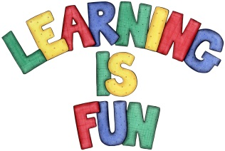
Date Set | 31.5.19
Date Due | 12.6.19
Mathletics | On Matheletics focus on knowing the names and recognising the properties of 2D and 3D shapes; as well as reflective symmetry. If children are confident in the 2, 5 and 10 times tables please start learning the 3, 4, 6, 7, 8 and 9 times tables. All activities can be found on matheletics.com. Every child has their username and passwords in their reading records.
Spellodrome  Writing | For your writing challenge you need to research one area of interest from below about the Ancient Greeks and create a factual poster about this historic era. You might want to research:  - Who were the Ancient Greeks?  - How did the Olympics begin?  - What was it like to live in an Ancient Greek family?  - Who were the Ancient Greek Gods, Goddesses and heroes?  - The Ancient Greeks at war  - What do we know about ancient Greek culture?  - How did the ancient Greeks change the world?  For your home learning project, you also need to make an Ancient Greek object from recyclable materials such as:  - Greek Vase  - Parthenon  - Ancient Greek Soldier helmet or shield  - Ancient Greek Jewellery  - Ancient Greek Coins or (anything else that you can think of!!!!)  Spellings to learn this week  - mind  - behind  - child  - children  - wild
Reading | Recommended daily reading time:  KS1 20 minutes.
Home Learning Project | Date Set: 31.5.19 Date Due: 10.6.19
Greek | Please go to Greek Class Blog for Greek Home Learning  Greek Class - St Cyprian's Greek Orthodox Primary Academy

