YEAR 1 HOME LEARNING
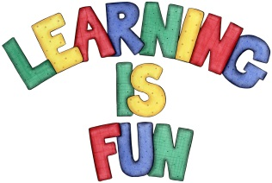
Date Set | 07.05.19
Date Due | 22.05.19
Mathletics | Place value, measurement, addition and subtraction.
Spellodrome  Writing | Set spellings: words with ff, ll, ss, zz, ck, nk. Words ending in y, er and est. words with digraphs.  Every Friday we will set a writing task using some key words. Please check your child’s Pink Home Learning book for more details.  Hand in: By the following Wednesday.
Reading | Recommended daily reading time:  KS1 15-20 minutes
Home Learning Project | Date Set: 07.05.19 Date Due: 22.05.19  Year 1 Home Learning  Our science topic this half term is ‘Materials’.  Your challenge is to create a moveable toy using different materials.  Your toy could be:  robot  car  doll house with doors/windows that open  Be as creative as possible. We look forward to seeing your creations!  If you need any help please see Miss Cabigas or Mrs Ahmed.
Greek | Please go to Greek Class Blog for Greek Home Learning  Greek Class - St Cyprian's Greek Orthodox Primary Academy
