YEAR 2 HOME LEARNING
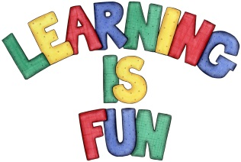
Date Set | 14.6.19
Date Due | 19.6.19
Mathletics | On Matheletics focus on solving measuring problems using grams and kilograms. Also focus on comparing and ordering mass. If children are confident in the 2, 5 and 10 times tables please start learning the 3, 4, 6, 7, 8, 9, 11 and 12 times tables. All activities can be found on matheletics.com. Every child has their username and passwords in their reading records.
Spellodrome  Writing | We have been reading the Legend of the Trojan War. This is the story of how the Greeks tricked the Trojans during the war by giving them a big wooden horse in which the Greek soldiers were hidden. For your writing challenge this week we would like you to imagine you are a Trojan and write a letter of complaint to the Greeks. You need to include in your writing:  - Detailed descriptions of how you are feeling with interesting adjectives avoiding happy and sad (e.g. ecstatic, angry, confused etc.)  - Conjunctions to extend your sentences (e.g. because, however, although, until, so etc.)  - Writing in the first person by using I.  - Some exclamation sentences that begin with what or how and end with a verb.  - Full stops and capital letters in the correct places.  Write at least a page for your letter.  Spellings to learn this week  - climb  - most  - only  - both  - old  - cold  - gold  - hold  - told  - every  - everybody
Reading | Recommended daily reading time:  KS1 20 minutes.
Home Learning Project | Date Set: Date Due:
Greek | Please go to Greek Class Blog for Greek Home Learning  Greek Class - St Cyprian's Greek Orthodox Primary Academy

