YEAR 2 HOME LEARNING
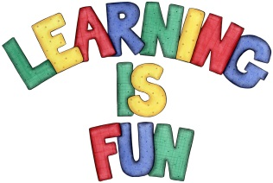
Date Set | 12.7.19
Date Due | 17.7.19
Mathletics | On Matheletics focus on compass directions and finding patterns of shapes and numbers. Also focus on reading data from Tally Charts, Pictograms and Bar Charts; as well as drawing the above graphs. If children are confident in the 2, 5 and 10 times tables please start learning the 3, 4, 6, 7, 8, 9, 11 and 12 times tables. All activities can be found on matheletics.com. Every child has their username and passwords in their reading records.
Spellodrome  Writing | We have been continuing to read ‘The Magic Finger’ by Roald Dahl focusing on his use of dialogue. For your writing challenge we would like you to create a conversation between two fairy tale characters of your choice. You need to include in your writing:  - Inverted commas (“”) around the parts which are spoken.  - Different words for said (shouted, screamed, whispered, exclaimed).  - Starting a new line each time your speaker changes.  - Conjunctions to extend your sentences (because, but, so, when, if)  - Include full stops and capital letters in all of the correct places.  Write at least a page for your conversation.  Spellings to learn this week:  - people  - water  - again  - half  - money  - parents  - Christmas
Reading | Recommended daily reading time:  KS1 20 minutes.
Home Learning Project | Date Set: Date Due:
Greek | Please go to Greek Class Blog for Greek Home Learning  Greek Class - St Cyprian's Greek Orthodox Primary Academy

