YEAR 2 HOME LEARNING
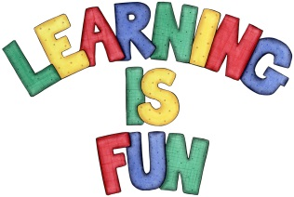
Date Set | 20.9.19
Date Due | 25.9.19
Mathletics | On Matheletics focus on Odd and Even numbers and finding patterns. Also focus on doubling and halving numbers and finding the multiples of the two times tables. All activities can be found on matheletics.com.
Spellodrome  Writing | Your home learning challenge this week is to make an information booklet about the Great Fire of London. You need to include:  - Factual information  - Headings and sub-headings such as: How do we know about the Great Fire of London? How did the Great Fire start? What happened after the Great Fire? How is the Great Fire remembered?  - Drawings and captions  - Information on Thomas Faynor, Samuel Peeps and Christopher Wren.  - Fun Facts  Spellings to learn this week  - age  - huge  - change  - charge  - bulge  - village
Reading | Recommended daily reading time:  KS1 20 minutes.
Home Learning Project | Date Set: N/A Date Due:
Greek | Please go to Greek Class Blog for Greek Home Learning  Greek Class - St Cyprian's Greek Orthodox Primary Academy

