YEAR 2 HOME LEARNING
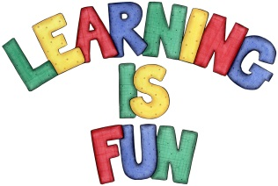
Date Set | 27.9.19
Date Due | 2.10.19
Mathletics | This week will be focussing on the multiples of 10 and adding and subtracting one and two digits mentally. We will also be focussing on measurement and calculating lengths of objects. All activities can be found on matheletics.com. Every child has their username and passwords in their reading records.
Spellodrome  Writing | The home learning challenge for this week is to write a book review about your all-time favourite book. You can choose any book you enjoy and must include the following points:  - What is the title?  - Who is the author and the illustrator?  - How many stars would you give the book?  - Who are the characters?  - Where is the story set? (forest, castle, small village, outer space etc.)  - What happened in the story?  - What is your favourite part?  - Why should someone read this book?  - You could also include a small picture of your character or the front cover.  You must write at least a page  Spellings to learn this week  - jacket  - jar  - jog  - join  - adjust
Reading | Recommended daily reading time:  KS1 20 minutes.
Home Learning Project | Date Set: N/A Date Due:
Greek | Please go to Greek Class Blog for Greek Home Learning  Greek Class - St Cyprian's Greek Orthodox Primary Academy

