YEAR 2 HOME LEARNING
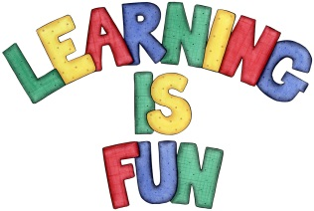
Date Set | 27.9.19
Date Due | 2.10.19
Mathletics | This week will be focussing on the multiples of 10 and adding and subtracting one and two digits mentally. We will also be focussing on measurement and calculating lengths of objects. All activities can be found on matheletics.com.
Spellodrome  Writing | The home learning challenge for this week is for you to create a character profile on one of your favourite characters from a story. The character can be from a fairy-tale, myth, legend or a fable. In your character profile you must include:  - Drawing of your character  - A description of what they look like and smell like etc. (be creative with your adjectives)  - A description of what they enjoy doing.  - A description of their personality (what is their personality like)  - Also include full stops, capital letters and finger spaces and ensure that your sentences make sense.  You must write at least a page.  Spellings to learn this week  - gem  - giant  - magic  - giraffe  - energy
Reading | Recommended daily reading time:  KS1 20 minutes.
Home Learning Project | Date Set: N/A Date Due:
Greek | Please go to Greek Class Blog for Greek Home Learning  Greek Class - St Cyprian's Greek Orthodox Primary Academy

