YEAR 6 HOME LEARNING
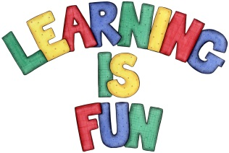
Date Set | 13.09.2019
Date Due | 18.09.2019
Spellings | Minimum of 10 minutes daily  cough  although  brought  thorough  vicious  ambitious  suspicious  delicious  cautious  infectious  mischievous  marvellous  conscious  disastrous  accommodate  communicate  exaggerate  appreciate  desperate  immediate
Reading | Recommended daily reading time:  KS2 40 minutes.
Writing | Your task this week is to write a story with the title ‘The Secret’.  You should spend 15 minutes planning the story and at least 45 minutes writing. Your story must be at least one and a half pages long.  Your story can be about anything you want, any genre but you need to remember to keep your reader interested!
Greek | Please go to Greek Class Blog for Greek Home Learning  Greek Class - St Cyprian's Greek Orthodox Primary Academy

