YEAR 4 HOME LEARNING
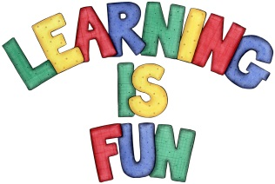
Date Set | 11/10/19
Date Due | 16/10/19
Mathletics | This week we will be looking at Venn diagrams and Carroll diagrams. Extra work will be put on mathletics for you to do at home.
Spellodrome | Spellodrome is not currently working, hopefully it will be updated soon.  This week children will be focusing on words with the sound /k/ spelt ch (Greek in origin).  - Choir  - Scheme  - Chorus  - Stomach  - Character  - Chaos  - Technology  - Chemist  - Mechanic  - anchor
Reading | Recommended daily reading time:  KS2 20 minutes.
Home Learning Project | This week for your home learning you will need to write a letter to a friend in another country about your week at school. You should remember to use: fronted adverbials, expanded noun phrases, subordinate clauses and coordinating conjunctions (FANBOYS). The home learning is due in on Wednesday 16th October.
Greek | Please go to Greek Class Blog for Greek Home Learning  Greek Class - St Cyprian's Greek Orthodox Primary Academy

