YEAR 2 HOME LEARNING
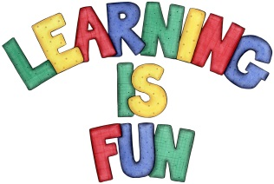
Date Set | 11.10.19
Date Due | 16.10.19
Mathletics | On Matheletics focus on the multiples of 2,3,5 and 10 and learning how to sequence numbers. Additionally, focus on calculating capacity using litres. All activities can be found on matheletics.com.
Spellodrome  Writing | The home learning challenge for this week is to think of at least ten questions that you would like to ask your all-time favourite hero. It could be someone famous such as a singer or a famous footballer. You might even decide to choose a super hero, book character or a family member or friend. You must also include:  - An introduction to who your hero is and why you have chosen them.  - A drawing or a photo of them with a caption.  - Remember to use capital letters, full stops and question marks!  You must write at least a page  Spellings to learn this week  - race  - ice  - cell  - city  - fancy
Reading | Recommended daily reading time:  KS1 20 minutes.
Home Learning Project | Date Set: N/A Date Due:
Greek | Please go to Greek Class Blog for Greek Home Learning  Greek Class - St Cyprian's Greek Orthodox Primary Academy

