YEAR 3 HOME LEARNING
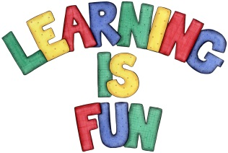
Date Set | 1/11/19
Date Due | 6/11/19
Mathletics | This week will be focusing our 2, 3, 4, 5, 8 and 10 times table as well as using the inverse to answer division questions. We will also be making and learning about properties of 3D Shapes. All activities can be found on matheletics.com. Every child has their username and passwords in their reading records.
Spelling  Writing  Home Learning Project | This week children will be focusing on these words:  chef moustache chalet parachute champagne brochure crochet machine ricochet chute  Writing Task  In class we have been learning how to use a dictionary, find meaning of words and write definitions of words. This week we would like you to put the words below in alphabetical order, use a dictionary to find the meaning of the words and write definitions. Write each word and definition in the new line e.g.  cheap – adjective  Something that is cheap doesn’t cost very much money.  horrid urge explode sort terrific mischief sloppiness tough gulp dose  Zakynthos Class Assembly is on the 1st November 2019.  Spetses Class Assembly is on the 8th November 2019.  Home Learning Project  Children are to create a book or a leaflet about living a healthy, active lifestyle. They can discuss things such as healthy eating, exercising and what our bodies need to stay healthy and strong. Due: November 1st 2019
Reading | Recommended daily reading time:  KS2 20 minutes.
Home Learning Project | Date Set:18.10.19 Date Due: 1.11.19
Greek | Please go to Greek Class Blog for Greek Home Learning  Greek Class - St Cyprian's Greek Orthodox Primary Academy

