YEAR 3 HOME LEARNING
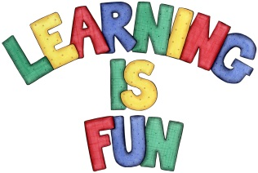
Date Set | 11.10.19
Date Due | 16.10.19
Maths | This week we have been focusing on multiples of 2,3,5,10.50 and 100. We have also answered questions by measuring using kilograms and grams. Please practice with children their 2, 3, 4, 5 and 10 times tables.
Spellings  Writing | This week children will be practising their spelling challenges, which are ‘ly’ suffixes in their home learning books.  This week’s spellings:  boldly bravely kindly clearly cleverly deadly  deeply exactly gladly kindly  Writing Task  In our Science lessons we have been learning about rocks, their appearance and physical properties. This week we would like you to write an information poster about different kinds of rocks and their properties Try to include:  - Title  - Headings and subheadings  - Statement sentences  - Interesting information  - Bullet points  - Captions  - Labels.  This home learning is due Wednesday 16th October 2019.  Zakynthos Class Assembly is on the 1st November 2019.  Spetses Class Assembly is on the 8th November 2019.
Reading | Recommended daily reading time:  KS2 20 minutes
Home Learning Project | Date Set: 13.09.19 Date Due: 4.10.19
Greek | Please go to Greek Class Blog for Greek Home Learning  Greek Class - St Cyprian's Greek Orthodox Primary Academy

